**How to backup Tenable Nessus Agents (1 time execution):**

1. Download the lasted version of the required Nessus agents from following location:

<https://www.tenable.com/downloads/nessus-agents>

Version 7.6.2 at the moment of creating this document

1. Connect to the AWS Management Console and switch to the ppv_role_admin @ ndm-ppv-npn
2. Go to the Amazon S3 > ndm-ppv-npn-common > nessus folder.
3. Create a new folder named “nessus-agent-7.6.2” using AWS-KMS encryption with the “ppv-npn-tenantx-byok1-us-east-1-key” key.
4. Upload the required Nessus agents into the folder created in step 4.

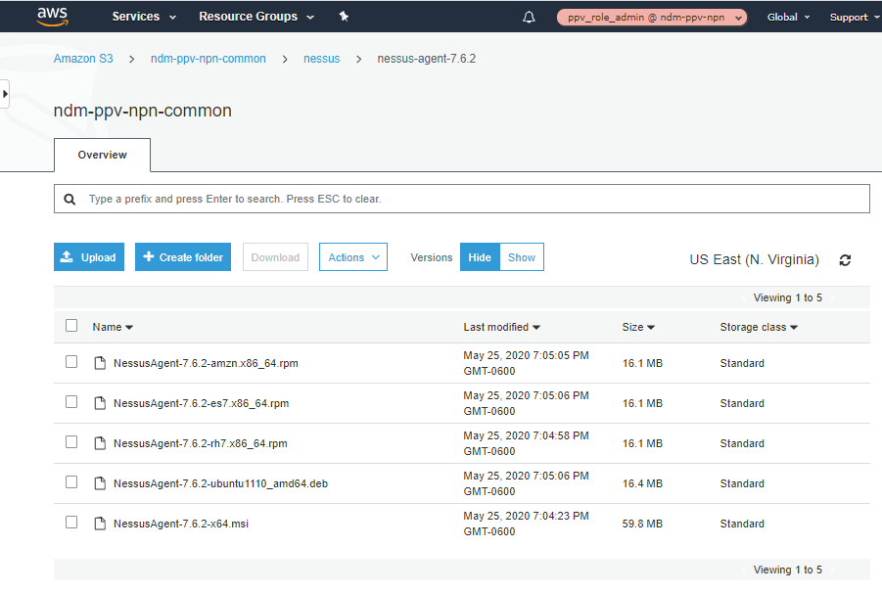

**How to create the distribution package (1 time execution):**

1. Download the installation scripts:

cd /repos

git clone git@git.mckinsey-solutions.com:mash-periscope/nessus-agent.git

1. For the required operating system version execute following steps in a temporary directory:

mkdir /tmp/nessus && cd /tmp/nessus

export AWS_PROFILE=ppv-admin-npn

aws s3 cp s3://ndm-ppv-npn-common/nessus/nessus-agent-7.6.2 . --recursive

Enter MFA code for arn:aws:iam::<account>:mfa/<email_address>@mckinsey.com: _

cp -f /repos/nessus-agent/tenableio/mdm-ppv-npn.sh tenableio.sh

cp -f /repos/nessus-agent/tenableio/mdm-ppv-npn.ps1 tenableio.ps1

cp -f /repos/nessus-agent/scripts/*.json .

cp -f /repos/nessus-agent/scripts/linux/* .

cp -f /repos/nessus-agent/scripts/windows/* .

zip NessusAgent-7.6.2-amzn.x86_64.rpm.zip *.sh tenableio *-7.6.2-amzn.x86_64.rpm

zip NessusAgent-7.6.2-es7.x86_64.rpm.zip *.sh tenableio *-7.6.2-es7.x86_64.rpm

zip NessusAgent-7.6.2-rh7.x86_64.rpm.zip *.sh tenableio *-7.6.2-rh7.x86_64.rpm

zip NessusAgent-7.6.2-ubuntu1110_amd64.deb.zip *.sh tenableio *.deb

zip NessusAgent-7.6.2-x64.msi.zip *.ps1 *.msi

**NOTE:** The mdm-ppv-npn.* files have the corresponding linking key and linking postfix group of the Nessus agent.

1. Compute the SHA256 message digest of the *.zip files and take note of the values.

sha256sum *.zip

1. Edit the manifest.json file to update the SHA256 field with corresponding values.
2. Upload the *.zip and *.json files into “s3://ndm-ppv-npn-common/nessus” folder

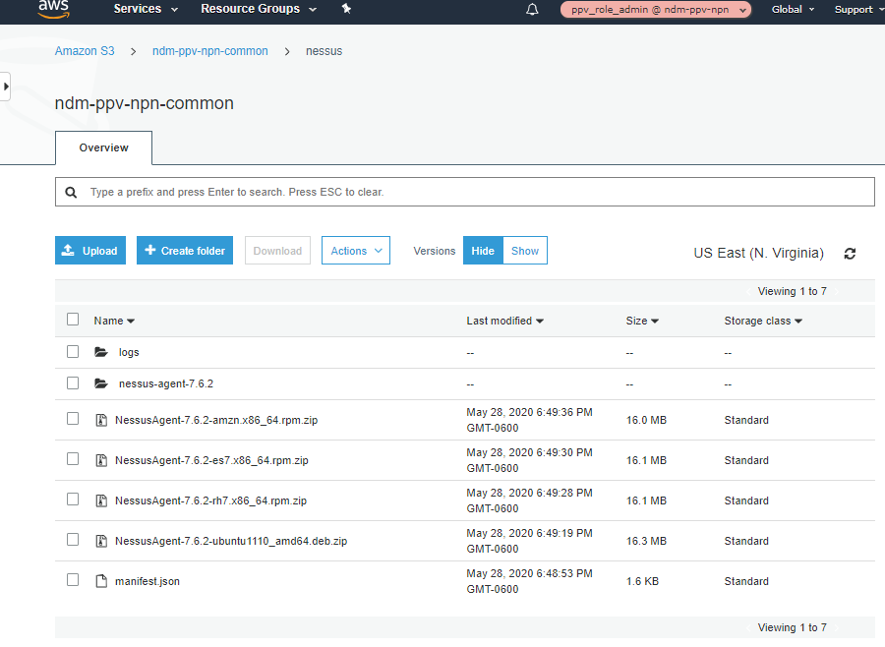

1. Go to AWS System Manager > Distributor > Create package
2. Select the “Advanced” option
3. Set the “Name” to “NessusAgent” in the “Details” section.

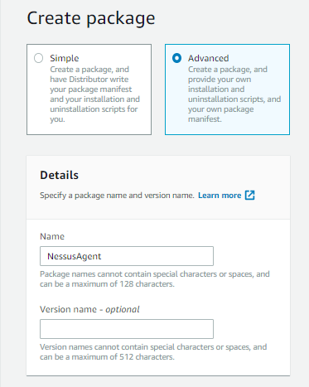

1. Set the “S3 bucket name” to “ndm-ppv-npn-common” and the “S3 key prefix” to “nessus” in the “Location” section. That is the S3 bucket where the package is located.

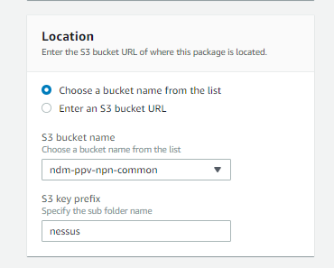

1. Select the “Extract from package” option in the “Manifest” section.

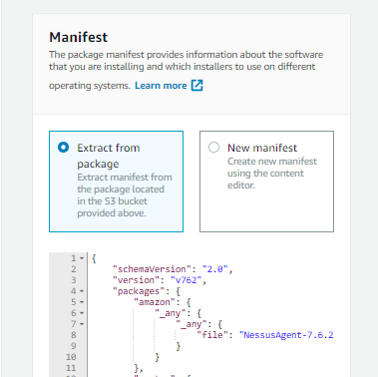

1. Select “Create package”. Wait until the status change to “Active”.

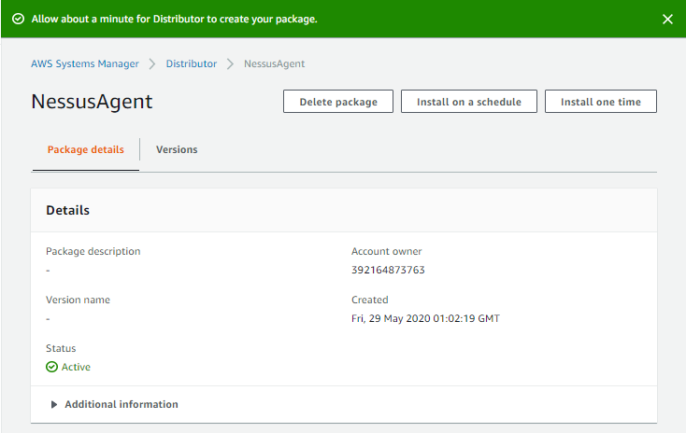

**How to execute the “NessusAgent” distributor package:**

1. **Prerequisites**:
2. Ensure that the EC2 instances where the Nessus agent is going to be installed have the “Name” and “Tenant” tags set to the right value, and with an “Instance State” of “running”.
3. Ensure that the corresponding Nessus agent group already exists in tenable.io.

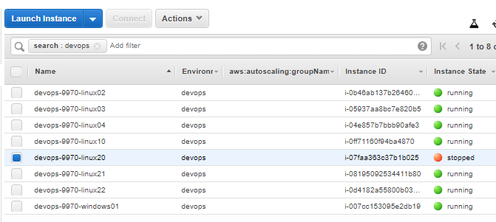

1. Go to AWS System Manager > Distributor > NessusAgent > Install one time.
2. Set “Action” to “Install” (or “Uninstall”) in the “Command parameters” section:

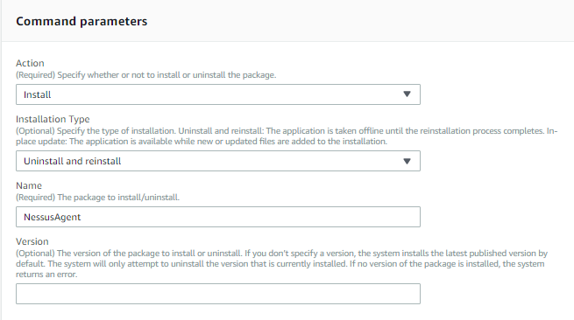

1. Select “Specify instance tags” in the “Targets” section
2. Specify “Environment” and “<Tag value>” (Example: devops, stg-tenant2, etc) and press “Add”

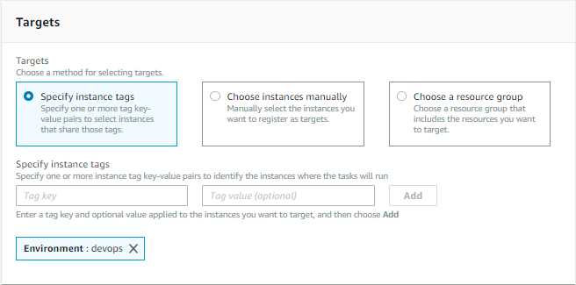

1. [Optional] Select “Enable writing to an S3 bucket” in the “Output options” section to write command output to an Amazon S3 bucket. Example:

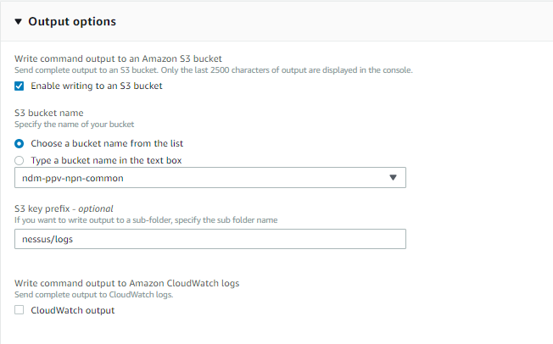

1. Select “Run” to deploy the Nessus agent on the selected EC2 instances

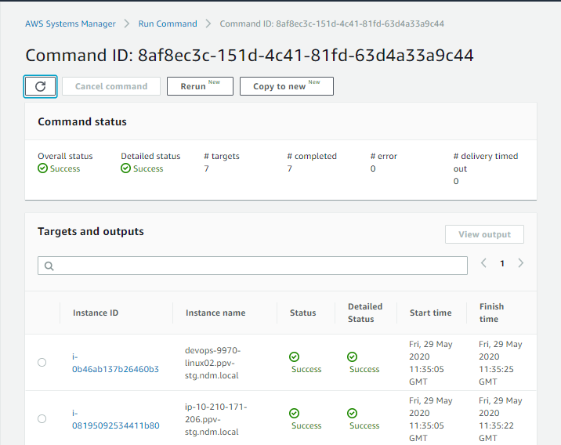

The installation can fail for the following reasons:

* + **Agent not showing EC2 instance in the list of instances available**

This problem is solved updating EC2Config in the EC2 instance. Could be necessary to do it manually.

* + **Error: Failed to retrieve manifest: ResourceNotFoundException: Could not find the latest version of package arn: aws: ssm ::: package / NessusAgent status code: 400, request id: 58abc7fc-886e-4f57-aa45-ba086a9ada57.**

This problem is solved by updating the SSM agent of the EC2 instance to the latest version.

* + **Failed to download manifest - failed to retrieve package document description: AccessDeniedException: User: arn: aws: sts :: XXXXXXXXX: assumed-role / ppv_svcrole_con_tenantNN / i-013e234e93ca9cc00 is not authorized to perform: ssm: DescribeDocument on resource: arn: aws: ssm: us-east-1: 949421251013: document / NessusAgent.**

This problem is solved by adding the AmazonSSMFullAccess policy to the corresponding IAM role of the instance.

* + **Install errors: sudo: sorry, you must have a tty to run sudo**

**sudo: sorry, you must have a tty to run sudo**

**sudo: sorry, you must have a tty to run sudo**

**failed to run commands: exit status 1**

**Failed to install package; install status Failed.**

This problem is unique to instances running under Red Hat Linux. The "requiredtty" is set in sudo config file "sudoers". When this flag is set, sudo can only be run from a login session and not via other means such as cron, shell, python or cgi-bin scripts. It is resolved by commenting out that entry in the sudo config file.